TCF Academic Catalog Addendum- Dated 4/29/2026

Page 22
Page 23
Page 40

There will no longer be any late registration fines in our academic catalog for returning students. The fee has been dropped from our fee schedule to allow an open registration at any time after the registration workshop has been held for the forthcoming semester or module.

I, Eric Bargerhuff, do hereby certify this addendum to be true and correct in content and policy. Our institution will adopt this addendum, effective 04/29/2026 and will incorporate it into our current catalog.

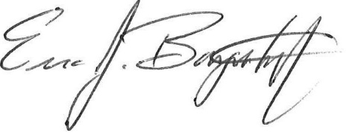 4/29/2026
_________________________________________________ _______________
Dr. Eric J. Bargerhuff, Vice President for Academic Affairs Date

